**A STUDY ON CAUSES AND EFFECTS OF MOBILE E-WALLETS USAGE AMONG MILLENNIUM**

Dissertation submitted in partial fulfilment of the requirements for the   
award of the Degree of

**MASTER OF BUSINESS ADMINISTRATION   
OF  
BANGALORE UNIVERSITY**

**  
SUBMITTED BY**

**NAGESHA A M  
 Reg. No: 191NCMD046**

**Under the guidance of**

**Mrs. JAMELA SALESTY**

**ASSOCIATE PROFESSOR, DEPARTMENT OF MANAGEMENT.**



**G.T INSTITUTE OF MANAGEMENT STUDIES AND RESEARCH**

**Sunkadakatte, Magadi Main Road, Bangalore - 560091  
Bangalore University   
2021**

**DECLARATION**

I hereby declare that the Dissertation titled **A STUDY ON CAUSES AND EFFECTS OF MOBILE E-WALLETS USAGE AMONG MILLENNIUM**

Is the result of the Dissertation carried out by me under the guidance of **Mrs. JAMELA SALESTY Associate Professor, Department of Management, G.T. Institute of Management Studies and Research, Sunkadakatte, Bangalore** in partial fulfilment for the awards of Master’s Degree in Business Administration by Bangalore University.

I also declare that this Dissertation is the outcome of my own efforts and that it has not been submitted to any other university or institute for the award of any other degree or diploma or certificate.

**Place: Bangalore Name: NAGESHA A M**

**Date: Register Number: 191NCMD046**

**GUIDE CERTIFICATE**

This is to certify that the Dissertation titled **A STUDY ON CAUSES AND EFFECTS OF MOBILE E-WALLETS USAGE AMONG MILLENNIUM**

Submitted by **Mr. NAGESHA A M(191NCMD046)** to Bangalore University, Bangalore, for the award of Degree of Master of Business Administration is a record of work carried out by him under my guidance.

**Place: Bangalore Signature**

**Date: Mrs. JAMELA SALESTY**

**GTIMSR**

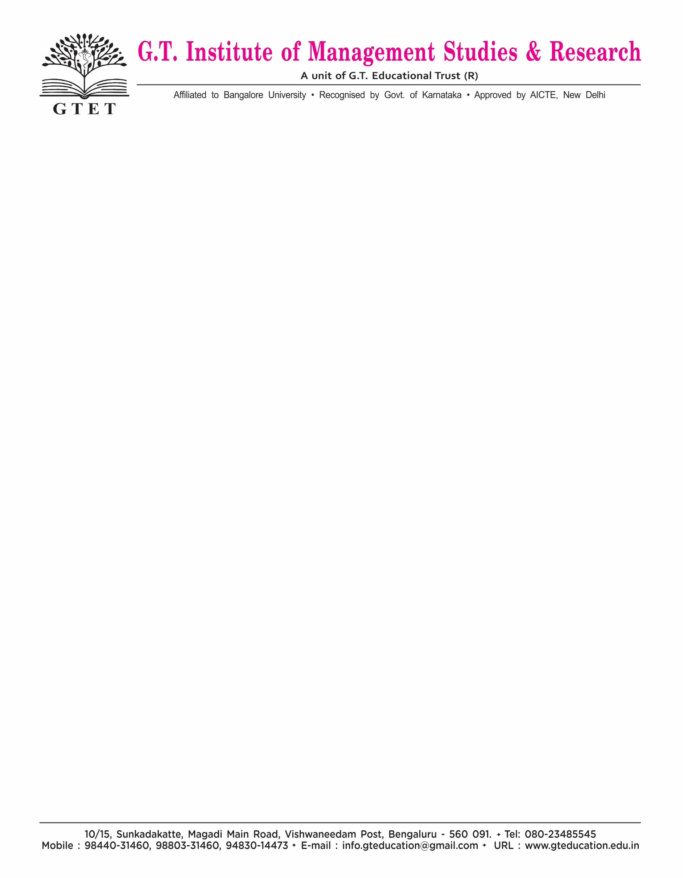

**CERTIFICATE OF ORIGINALITY**

This is to certify that the Dissertation titled **A STUDY ON CAUSES AND EFFECTS OF MOBILE E-WALLETS USAGE AMONG MILLENNIUM**

is an original work of **Mr. NAGESHA A M** bearing University Register Number **191NCMD046** and is being submitted in partial fulfilment for the award of the Master’s Degree in Business Administration of Bangalore University. The report has not been submitted earlier either to this University /Institution for the fulfilment of the requirement of a course of study. **Mr. NAGESHA A M** is guided by **Mrs. JAMELA SALESTY** Who is the Faculty Guide as per the regulations of Bangalore University.

Signature of Faculty Guide Signature of Director / Principal /HOD

Date Date

**BANGALORE UNIVERSITY**

Certificate of Originality (Plagiarism)

**Name of the Student : NAGESHA A M**

**Registration Number: 191NCMD046**

**Title of Dissertation: A STUDY ON CAUSES AND EFFECTS OF MOBILE**

**E-WALLETS USAGE AMONG MILLENNIUM**

**Name of the guide: Mrs. JAMELA SALESTY**

**Similar Content (%) Identified: 7 %**

**(Acceptable maximum limit of similarity 25%)**

**Dissertation work ID number (S) in:** **1655658527**

The Dissertation report has been checked using DrillBit Plagiarism Detection Software (attach first page of the originality report as ANNEXURE) and found within limits as per plagiarism policy and instructions used by the **UNIVERSITY.**

We have verified the contents of the Dissertation reports, as summarized above and certified that the statements made above are true to the best of our knowledge and belief.

**Signature of Guide** **Signature of the Principal/Director**

Date Date & Seal

**ACKNOWLEDGEMENT**

I offer my most sincere and grateful acknowledgement to GT Institute of Management Studies and Research which enabled me to pursue the Master of Business administration (MBA) to Bangalore University.

I take immense pleasure in thanking my beloved director Dr.B.G. SATYAPRASAD for having permitted me to carry out this Dissertation work.

I wish to express my deep sense of gratitude to my internal guide, Mrs. JAMELA SALESTY G T Institute of Management Studies and Research for is able guidance and useful suggestions which helped me in completing the project in time.

Finally, yet importantly, I would like to express my heartfelt thanks to my beloved parents for their blessings and friends for helping and wishing for successful completion of this project.

**NAGESHA A M**

**(REGISTER NO: 191NCMD046)**

**TABLE OF CONTENTS**

|  |  |  |
| --- | --- | --- |
| **CHAPTERS** | **PARTICULARS** | **PAGE NO** |
| **1** | **INTRODUCTION** | **1-20** |
| **2** | **RESEARCH DESIGN** | **21-29** |
| **3** | **COMPANY PROFILE** | **30-53** |
| **4** | **DATA ANALYSIS AND INTERPRETATION** | **54-83** |
| **5** | **FINDINGS, SUGGESTIONS AND CONCLUSION** | **84-87** |
|  | **BIBLIOGRAPHY** |  |
|  | **ANNEXURE** |  |

**LIST OF TABLES**

|  |  |  |
| --- | --- | --- |
| Table No | Description | Page No |
| 4.1 | Table showing the gender category of respondents. | 55 |
| 4.2 | Table showing the Age category of respondents. | 57 |
| 4.3 | Table showing the martial status of respondents. | 59 |
| 4.4 | Table showing the occupation respondents. | 61 |
| 4.5 | Table showing the educational qualification of respondents. | 63 |
| 4.6 | Table showing the income level of the[in Rs] of respondents. | 65 |
| 4.7 | Table showing the uses mobile e-payment for various financial transaction. | 67 |
| 4.8 | Table showing the mobile e-payment , are the main reasons for not using this . | 69 |
| 4.9 | Table showing numbers of mobile e-wallets . | 71 |
| 4.10 | Table showing the payment with regard to mobile e-payment. | 73 |
| 4.11 | Table showing the reasons for choosing mobile e-payment . | 75 |
| 4.12 | Table showing the overall experience of mobile e-payment (digital and online payment) systems overall experience of mobile e-payment . | 77 |

|  |  |  |
| --- | --- | --- |
| 4.13 | Table showing the level of satisfaction through the products and its various features offered by your mobile e-wallet payment services | 79 |
| 4.14 | Table showing the level of satisfaction through the customers services offered by your mobile e-wallet payment services. | 81 |
| 4.11 | Table showing the satisfaction level through customer care services. | 58 |
| 4.12 | Table showing the satisfaction level through network available. | 60 |
| 4.13 | Table showing the satisfaction level of current internet facility. | 62 |
| 4.14 | Table showing the satisfaction level through promotional activity. | 64 |
| 4.15 | Table showing the Recompense additional benefits provided. | 66 |
| 4.16 | Table showing the happiness through network availability in travelling. | 68 |
| 4.17 | Table showing the satisfaction level regarding call charges. | 70 |
| 4.18 | Table showing the Brand preference of the customers. | 72 |
| 4.19 | Table showing the acceptance of offers & services provided. | 74 |
| 4.20 | Table showing the source of knowledge about broadband& telecommunication. | 76 |
| 4.21 | Table showing the factors that influence to buy any services. | 78 |
| 4.22 | Table showing the problems that needs customer care services. | 80 |
| 4.23 | Table showing the opinion regarding performance of product. | 82 |

**LIST OF GRAPHS**

|  |  |  |
| --- | --- | --- |
| Graph No | Description | Page No |
| 3.1 | Graph showing the gender category of respondents. | 34 |
| 3.2 | Graph showing the age classification of respondents. | 35 |
| 3.3 | Graph showing the Occupations of respondents. | 36 |
| 3.4 | Graph showing the Segment of respondents. | 37 |
| 4.1 | Graph showing the Brand awareness of airtel & BSNL. | 39 |
| 4.2 | Graph showing the services used by customer. | 41 |
| 4.3 | Graph showing the Satisfaction level of changes charged by service provider compared to another operator. | 43 |
| 4.4 | Graph showing the knowledge of tariff plan among the customer. | 45 |
| 4.5 | Graph showing the customer’s opinion regarding the quality of broadband and telecommunication. | 47 |
| 4.6 | Graph showing the satisfaction of current tariff& offer among customer. | 49 |
| 4.7 | Graph showing the customer’s opinion regarding the quality of broadband & telecommunication. | 51 |
| 4.8 | Graph showing recommendation by the customer. | 53 |
| 4.9 | Graph showing the opinion regarding current service provided by the company. | 55 |

|  |  |  |
| --- | --- | --- |
| 4.10 | Graph showing the suggestion about the aspect which needs immediate improvement. | 57 |
| 4.11 | Graph showing the satisfaction level through customer care services. | 59 |
| 4.12 | Graph showing the satisfaction level through network available. | 61 |
| 4.13 | Graph showing the satisfaction level of current internet facility. | 63 |
| 4.14 | Graph showing the satisfaction level through promotional activity. | 65 |
| 4.15 | Graph showing the Recompense additional benefits provided. | 67 |
| 4.16 | Graph showing the happiness through network availability in travelling. | 69 |
| 4.17 | Graph showing the satisfaction level regarding call charges. | 71 |
| 4.18 | Graph showing the Brand preference of the customers. | 73 |
| 4.19 | Graph showing the acceptance of offers & services provided. | 75 |
| 4.20 | Table showing the source of knowledge about broadband& telecommunication. | 77 |
| 4.21 | Graph showing the factors that influence to buy any services. | 79 |
| 4.22 | Graph showing the problems that needs customer care services. | 81 |
| 4.23 | Graph showing the opinion regarding performance of product. | 83 |